Modern Negro Art Word Count: 545

Modern Negro Art by James A. Porter (1905-1970) is a ground-breaking historical study of African American art from slavery to the early twentieth century. The first major text of its kind following Alain Locke’s ground-breaking The New Negro (1925), it was the main source of information on African American artists until comparable historical surveys were published in the 1970s. The book presents an overview of artists’ biographies with analysis of the style and subject matter of their work. The “The New Negro Movement” chapter lays out Porter’s main argument against Locke’s well-established racialist position. Locke advocated for the development of a “Negro art” that would counter negative stereotypes and present a more appealing image of the New Negro to American society. Countering Locke, Porter argued that seeking to “exploit the ‘racial concept’” limited the potential expression African American artists. Instead he advocated for a treatment of African American art as already integral to the history of American art. Rejecting Locke’s emphasis on an African ancestral heritage, Porter demonstrated the historical development of African American art in North America from slavery to the early twentieth century. His research and thorough attention to overlooked African American artists remain among of the book’s most vital contributions to the field of art history and accounts for the book’s continuing impact.

Porter was himself an accomplished artist, trained at Howard University in Washington D.C. (1923-1927). After he graduated, he taught painting and drawing at Howard and eventually continued his studies in painting and art history in New York and Paris. In 1933, Porter won the Schomberg Portrait Prize from the Harmon Foundation for Woman Holding a Jug (1930), earning him national attention. Porter continued to paint throughout his life. His early realism gave way to a more expressive mode of painting when he traveled to West Africa in 1963. The impetus for Modern Negro Art came from Porter’s experience as an artist who, despite his success, was met with condescension because of his race. Porter realised the need for recognition to help encourage and improve opportunities for black artists across the U.S. To this end, he earned a masters in art history from New York University in 1937; his masters thesis was the basis for the book manuscript that would be published as Modern Negro Art. Porter’s wife Dorothy, the director of the Moorland-Spingarn Research Center at Howard, assisted him in his research and prepared the extensive bibliography for the book. The book was well-received by African American artists and intellectuals and its enthusiastic reception among art students prompted Porter to teach a course in African and African American art at Howard. Later, when he became the director of the Howard University Gallery of Art, Porter scheduled solo exhibitions for the day’s leading African American artists, including Archibald J. Motley, Jr., Charles White, and Eldizer Cortor. As in his scholarship, Porter’s leadership at Howard focused on promoting the overlooked works by African American and later Afro-Caribbean artists.

References and further readings:

Bearden, R. and H. Henderson. (1993) A History of African-American Artists: From 1792 to the Present, New York: Pantheon.

Morrison, K. (2011) “Art Criticism: A Pan-African Point of View, February 1979” in The Essential New Art Examiner, Dekalb, IL: Northern Illinois University.

Porter, J. A. (1943) Modern Negro Art, New York: Dryden Press.

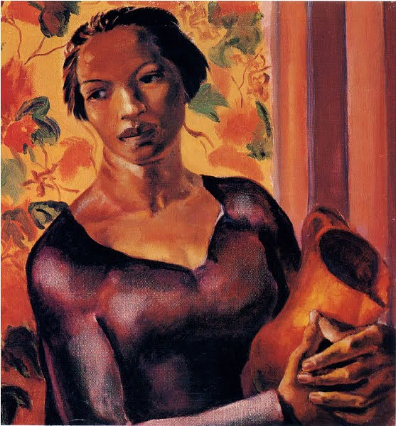
James A. Porter, Woman Holding a Jug, 1930, 21 1/4 x 23 in., Carl Van Vechten Gallery of Fine Arts, Fisk University, Nashville
http://www.fisk.edu/services-resources/fisk-university-galleries/the-carl-van-vechten-gallery

